**HOMEWORK 1**

1-List employees’ first name and last name in same department in one row.  
 Firstname Lastname; Firstname Lastname ;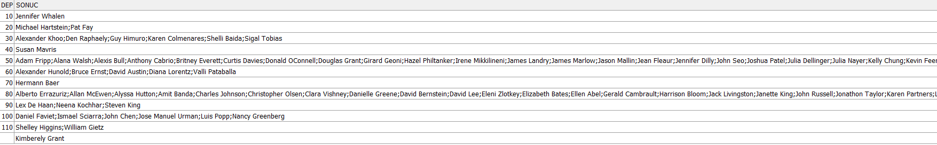

**SELECT**

**e1.department_id,**

**LISTAGG(e1.first_name || ' ' || e1.last_name, ', ') WITHIN GROUP (ORDER BY e1.first_name, e1.last_name) AS Employees**

**FROM**

**employees e1**

**GROUP BY**

**e1.department_id**

**ORDER BY**

**e1.department_id;**

metin, ekran görüntüsü, yazı tipi, cebir içeren bir resim

Açıklama otomatik olarak oluşturuldu

**HOMEWORK 2**

Write a SQL statement that shows employees’ preceeding 1 and following 1 salary totals in same job_id and ordered by hiredate.

**SELECT**

**employee_id,**

**first_name,**

**last_name,**

**job_id,**

**hire_date,**

**salary,**

**COALESCE(LAG(salary, 1) OVER (PARTITION BY job_id ORDER BY hire_date), 0) AS Preceding_Salary,**

**COALESCE(LEAD(salary, 1) OVER (PARTITION BY job_id ORDER BY hire_date), 0) AS Following_Salary,**

**salary +**

**COALESCE(LAG(salary, 1) OVER (PARTITION BY job_id ORDER BY hire_date), 0) +**

**COALESCE(LEAD(salary, 1) OVER (PARTITION BY job_id ORDER BY hire_date), 0) AS Total_Salary**

**FROM**

**employees**

**ORDER BY**

**job_id,**

**hire_date;**

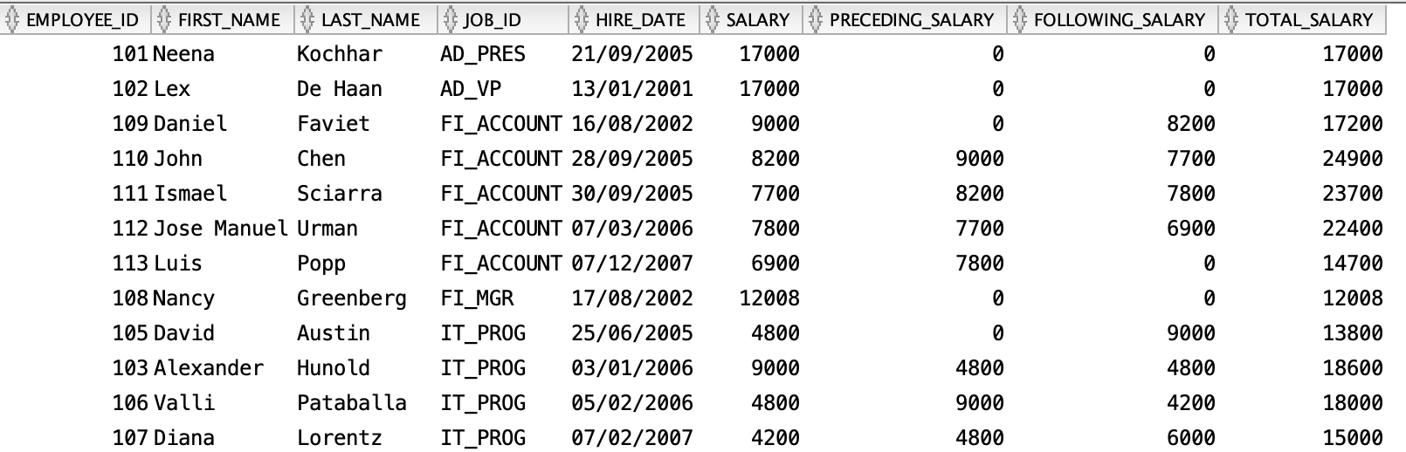

**HOMEWORK 3**

List employees’ salary orders in their department and exclude higest salaried employee.

**SELECT**

**EMPLOYEE_ID,**

**FIRST_NAME,**

**LAST_NAME,**

**DEPARTMENT_ID,**

**SALARY**

**FROM (**

**SELECT**

**EMPLOYEE_ID,**

**FIRST_NAME,**

**LAST_NAME,**

**DEPARTMENT_ID,**

**SALARY,**

**ROW_NUMBER() OVER (PARTITION BY DEPARTMENT_ID ORDER BY SALARY DESC) AS SALARY_RANK**

**FROM**

**EMPLOYEES**

**) RANKED_SALARY**

**metin, yazı tipi, ekran görüntüsü, beyaz içeren bir resim

Açıklama otomatik olarak oluşturulduWHERE**

**SALARY_RANK > 1**

**ORDER BY**

**DEPARTMENT_ID,**

**SALARY_RANK;**

**HOMEWORK 4**

Listemployees’ hire order according to hiredate year value.

**SELECT**

**EMPLOYEES.*,**

**EXTRACT(YEAR FROM HIRE_DATE) AS HIRE_YEAR**

**FROM**

**EMPLOYEES**

**ORDER BY**

**HIRE_DATE;**

metin, ekran görüntüsü, yazı tipi, sayı, numara içeren bir resim

Açıklama otomatik olarak oluşturuldu

**HOMEWORK 5**

List employees’ firstname, lastname, salary and salaries of employees’ hired before and after this employee according to hirededate.

**SELECT**

**employee_id,**

**first_name,**

**last_name,**

**salary,**

**LAG(salary, 1, NULL) OVER (ORDER BY hire_date) AS Previous_Salary,**

**LEAD(salary, 1, NULL) OVER (ORDER BY hire_date) AS Next_Salary**

**FROM**

**employees**

**ORDER BY**

**hire_date;**

metin, ekran görüntüsü, menü, sayı, numara içeren bir resim

Açıklama otomatik olarak oluşturuldu